1. **Create one VPC,with 1 one public subnet and 1 private subnet.**

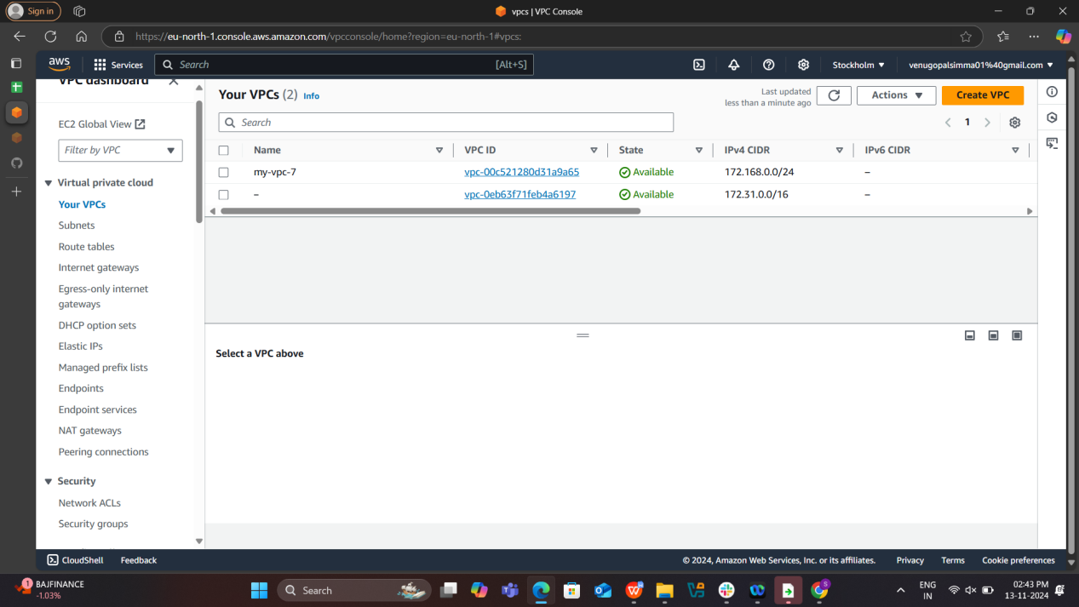

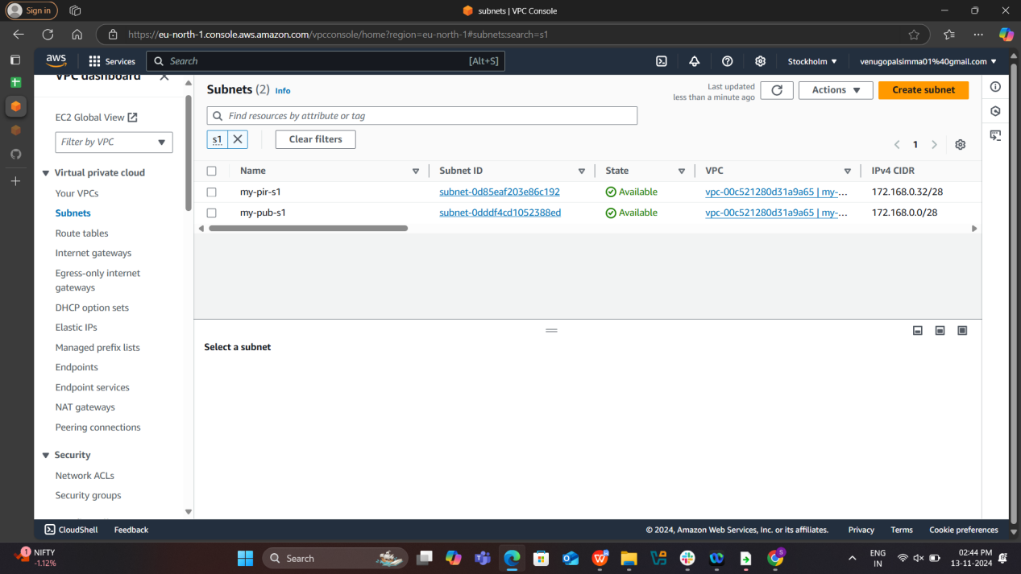

**2) Enable VPC peering for cross region.**

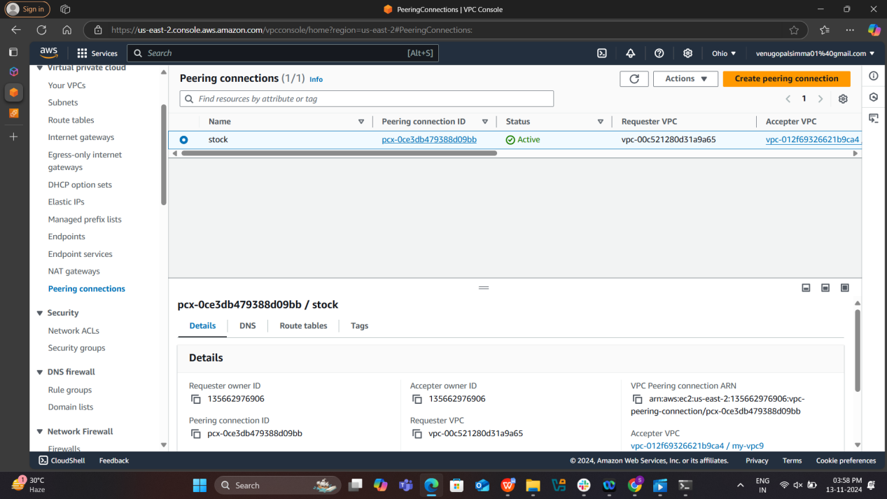

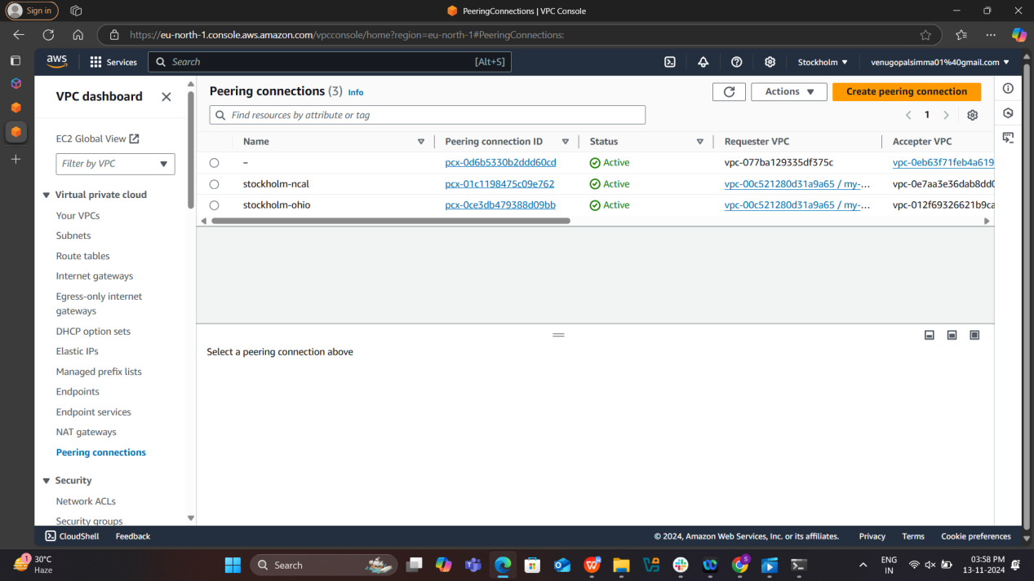

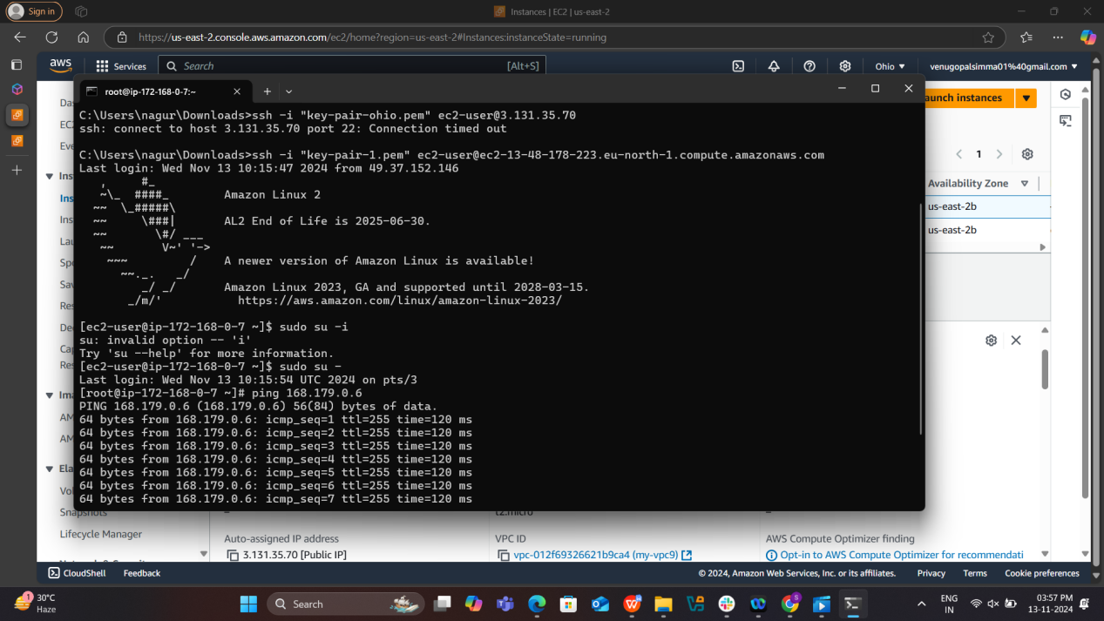

**3) . Enable VPC peering for cross account. (You can collaborate with your friend and do this task).**